https://www.legacy.com/us/obituaries/fredericknewspost/name/paul-donnelly-obituary?id=10116288

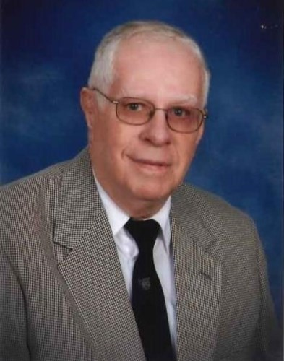
Paul Boyce Donnelly, Sr., age 86, of Frederick, MD, passed away peacefully at Frederick Memorial Hospital in the Hospice Care Unit on Saturday, July 6th, 2019. He was born in 1932 in Providence, Rhode Island. Paul was the son of the late Francis J. Donnelly and Mildred H. (Boyce) Donnelly. He was the loving husband of Marie Rose (Fiorino) Donnelly for almost 50 years when she passed away in 2009.
Paul was a 1950 graduate of La Salle Academy in Providence, RI and then attended Providence College. He received his B.S. degree in 1955 from the Rhode Island College of Pharmacy and Allied Sciences which is where he met his future wife who was also a 1955 graduate. After graduation, he joined the U.S. Navy and graduated from the U.S. Naval Officers Candidate School in Newport, RI. He was commissioned as an officer in the Medical Service Corp and worked as a pharmacist in Naval hospitals. Paul was married in 1960 and relocated to Beaufort, South Carolina. Several years later he earned his Masters Degree from the University of Rhode Island. He retired in 1975 after 20 years in the Naval Medical Service Corp as a Lt. Commander. Following his Navy retirement, he took a job with the Food and Drug Administration in Rockville, MD. At that time, he relocated his family to Frederick. Paul retired in 1997 after working for the FDA for 20 years. In 2006 Paul and his wife became residents of Homewood at Crumland Farms. At the time of his death, he was living in the Health Care Center at Homewood.
Paul was a member of Saint Katherine Drexel Catholic Church. He arranged the weekly shuttle bus transport to the church and distributed bulletins to Homewood residents who were unable to get to church. He sang in the Homewood Choir. He was a member of the Knights of Columbus, the Military Officers Association of America, the American Pharmaceutical Association and the National Association for Uniformed Services.
He is survived by three children: Rosemarie (Donnelly) Festog (husband Monte) of Myersville, MD, Margaret (Donnelly) Ramos (husband Les) of Weatherford, OK and Patrick Donnelly (wife Julie) of Walkersville, MD; five grandchildren: Matt Festog, Kristen Festog, Danny Festog, Nicholas Ramos and Cathy Donnelly; a sister-in-law: Lorita Jussila (husband Peter) of Warwick, RI. In addition to his wife, he was preceded in death by his son Paul Boyce Jr. in 1995 and his two brothers: Francis J. Donnelly and the Rev. Richard A. Donnelly.
The family would like to thank the entire staff at Homewood at Crumland Farms for the excellent care that Dad received for 13 years. They would also like to thank the doctors and nurses at FMH for the wonderful care provided to Dad and the compassionate, caring staff of the Hospice Care Unit for making it possible for Dad to pass from this world peacefully and with dignity.
Family members will receive condolences from family and friends on Sunday, July 14th, from 6-8pm at Stauffer Funeral Home, 1621 Opossumtown Pike. A Catholic mass will be held on Monday, July 15th at 1pm at Saint Katherine Drexel Church on Opossumtown Pike. Paul will be buried with his wife at St. Ann's Cemetery in Cranston, Rhode Island.
In lieu of flowers, donations may be made in Paul Boyce Donnelly, Sr.'s name to The Saint Katherine Drexel Building Fund or to The Homewood Foundation.
